Asian Monsoon Flood Risk Analysis
AWS Project Report
Subheading: AWS Cloud ETL Data Pipeline & Analytics Report
AWS Services: Amazon S3 | AWS Glue | AWS Crawler | AWS Data Catalog | AWS IAM | Amazon Athena | SQL
BI & Visualization: Power BI Desktop | Simba Athena ODBC Driver | DAX Metrics

Project Overview
- Analyses hydrological vulnerability, monsoon intensity, land use modifications (deforestation and urban cover), and flood occurrences across key South and Southeast Asian river basins (Ganges-Brahmaputra, Indus, Mekong Delta, Chao Phraya, Ayeyarwady, and Red River).
- Implements a cloud ETL pipeline to ingest, catalogue, and query raw telemetry and index metrics directly from object storage without dedicated database provisioning.

Key Objectives
  - Collect and structure hydrological and climatological risk indicators across 15,000 regional observations.
  - Build a scalable AWS data lake architecture using Amazon S3 and AWS Glue.
  - Execute schema discovery and SQL-based transformations via Amazon Athena.
  - Establish live ODBC connectivity between Athena and Power BI for executive dashboard reporting.

AWS Architecture & ETL Workflow Steps
AWS Services :

Step 1:
Create AWS Management Account and Login

AWS Homepage :


Step 2:
In Search Bar – Type S3 Bucket ( Simple Scalable Storage )
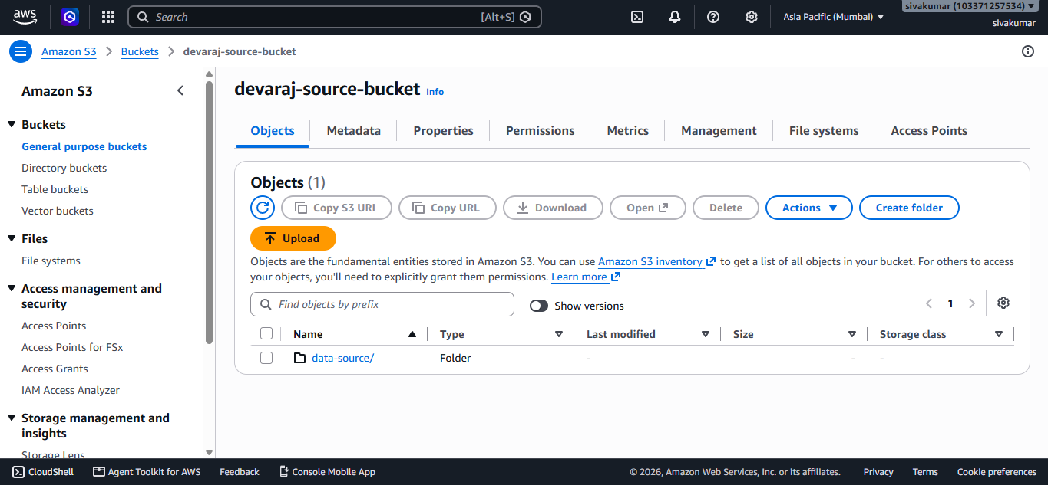
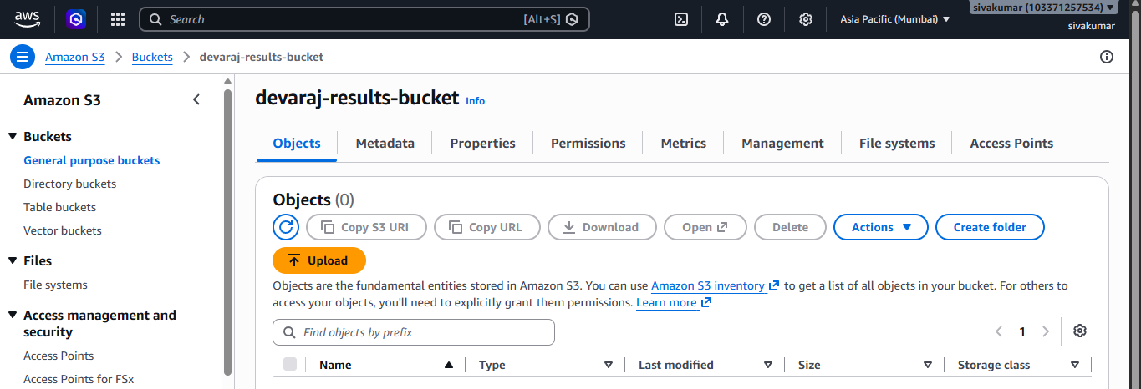
I Have Created 2 S3 Buckets
  - devaraj-source-bucket – To Upload the Dataset
  - devaraj-results-bucket – To Save the Results
Step 3 :
Inside the Bucket – ( Devaraj-source-bucket ) > Create Folder and Upload a Dataset File
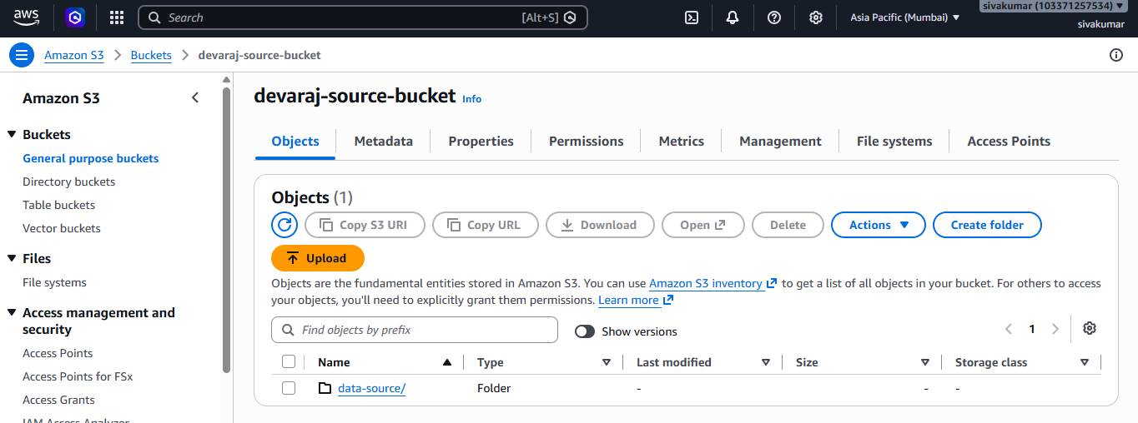
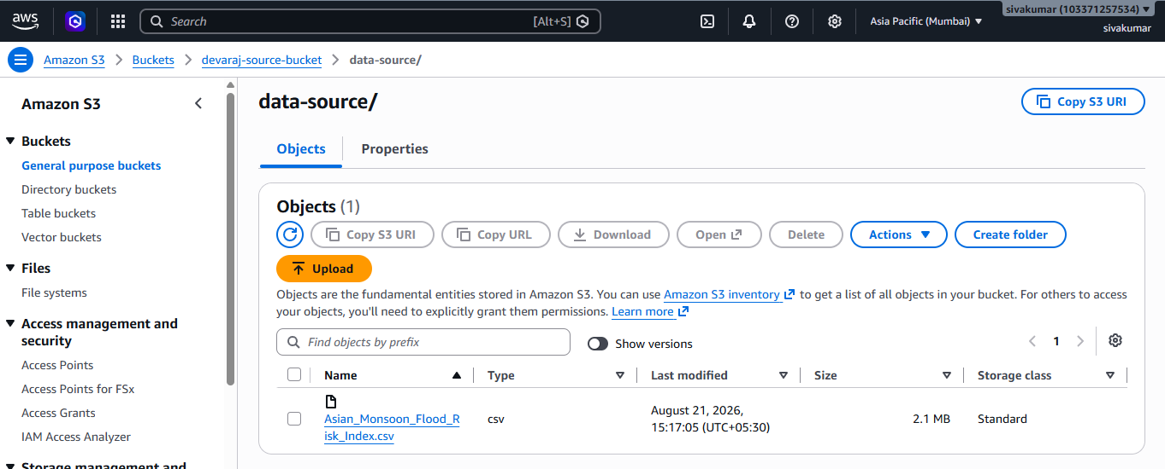

Step 4 :
Create IAM Role – Assign Permission the Glue Services to Access the Buckets.
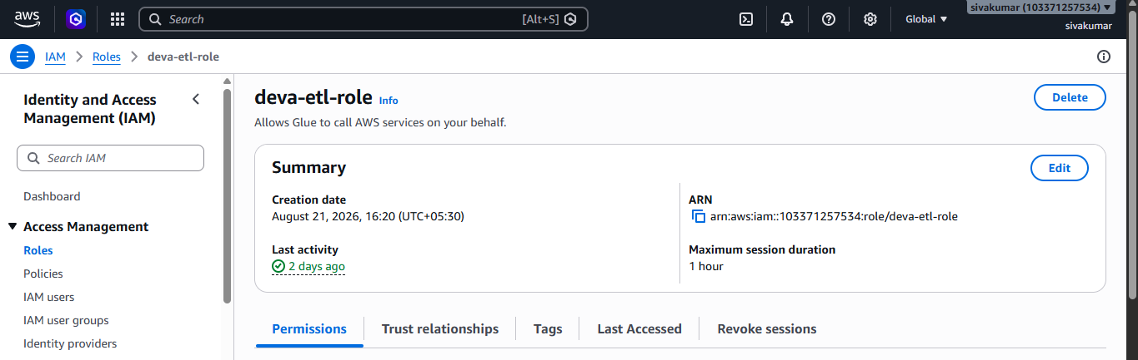


Step 5 :
In AWS Glue Services
  - Create Crawler
  - Database
  - Tables
  - Create Query
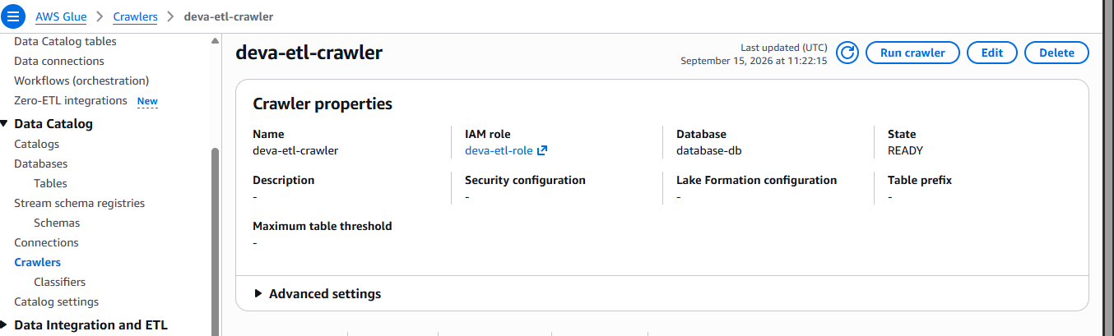

Step 6 :
Search Athena and start Write Query
AWS Athena is a serverless query service that lets you analyze data directly from Amazon S3 using SQL.
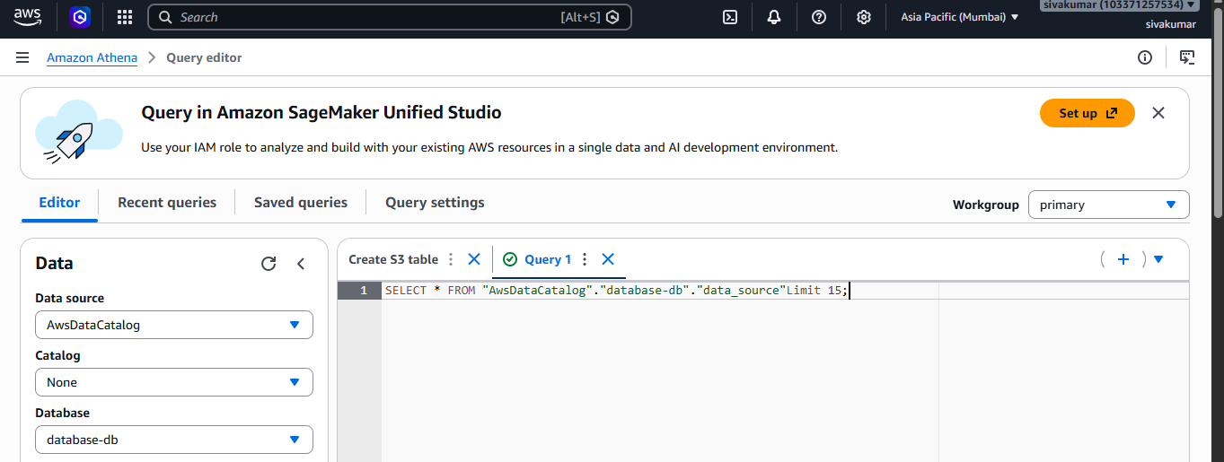
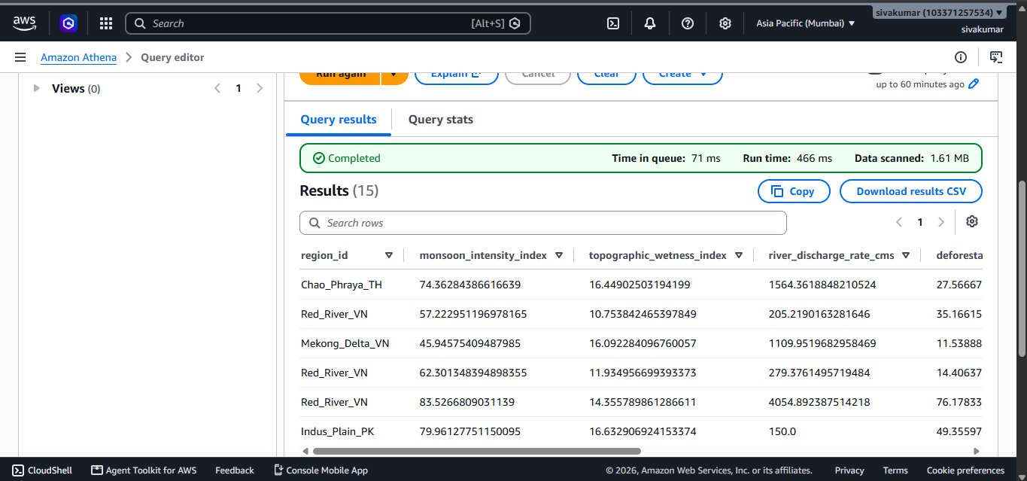
I Retrieve the Data of Flood Analyze Using Athena
Step 7 :
SQL Queries
- Record Count per River Basin / Region
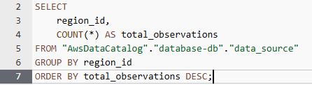
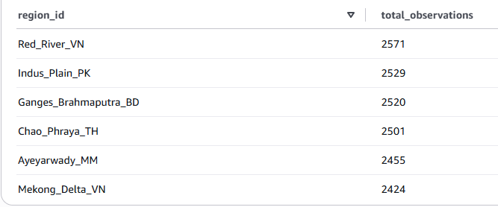

- Average Monsoon Intensity and Topographic Wetness by Region
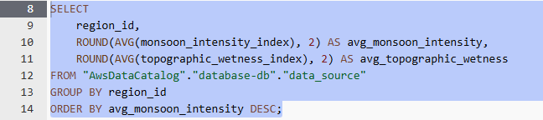
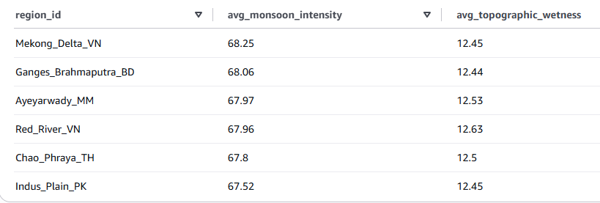

- Regional River Discharge Summary (Min, Max, and Average)
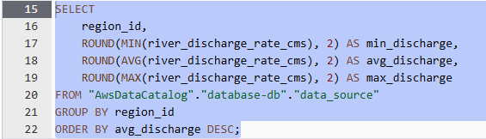
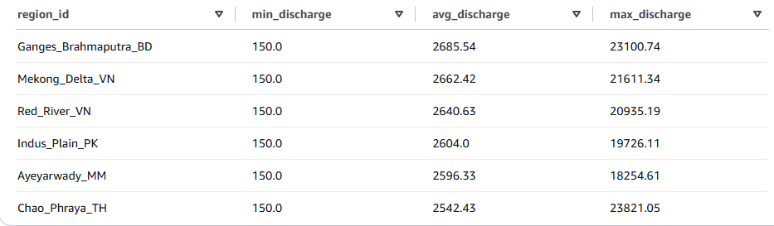

- Total and Rate of High-Risk Flood Events (Binary Target = 1)
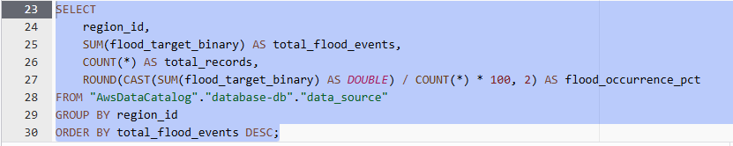
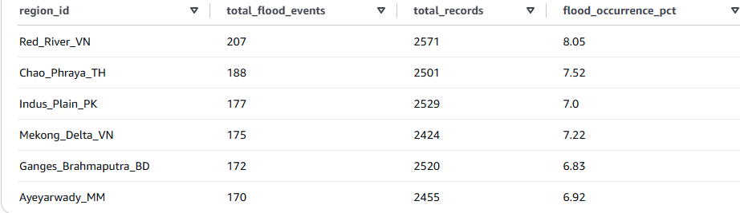

- Mean Flood Probability by River Basin
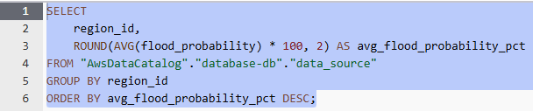
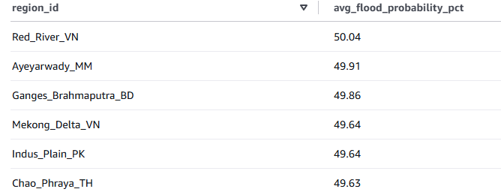

- Deforestation and Urban Impervious Surface Levels by Basin
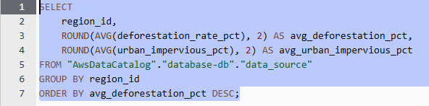
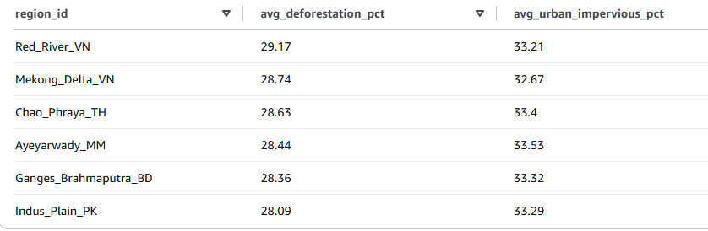

- Top 10 Extreme River Discharge Records
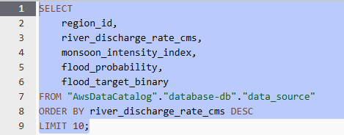
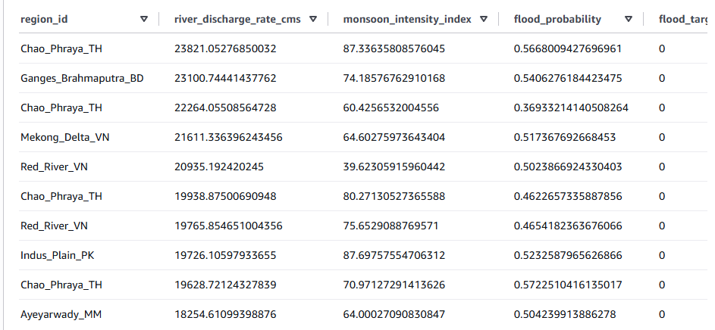

- Soil Moisture Anomaly vs. Actual Flood Occurrence
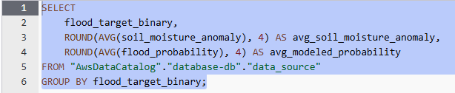
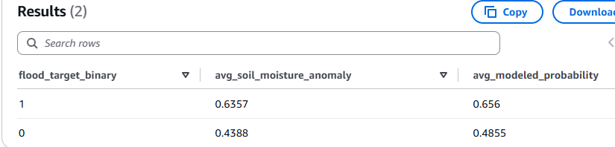

- Flood Risk Stratification by Urban Impervious Tier
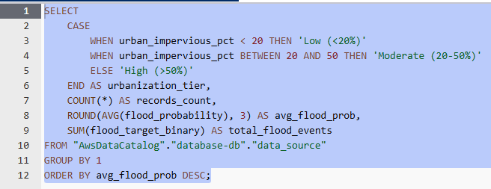
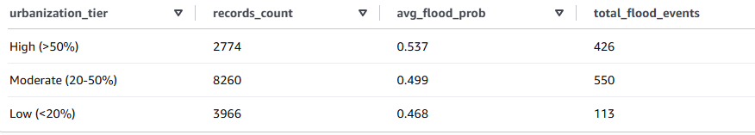

- High Environmental Vulnerability Zones (High Deforestation + High Runoff)
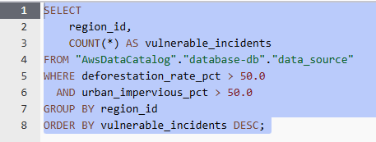
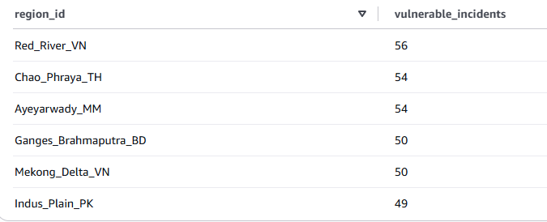

Step 8 :
I connect the dataset to power bi through ODBS Software.
  - Installed the Simba Amazon Athena ODBC driver on windows
  - This ODBC connection allows Power Bi to query the Athena table directly.
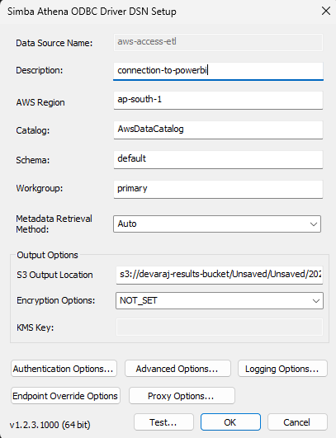

Step 9 :
I Have Created Interactive Dashboard Using PowerBI
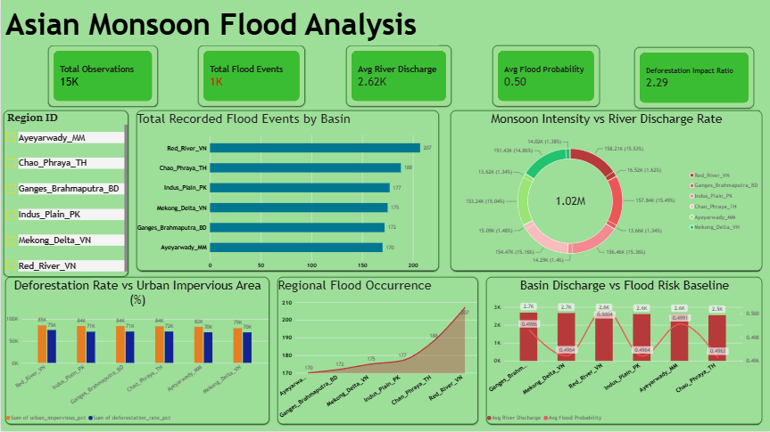

Key Analytical Insights
- Geographic Vulnerability Skew: Red River (VN) (207 events) and Chao Phraya (TH) (188 events) emerge as the primary regional hotspots, experiencing substantially higher flood frequencies than Ayeyarwady (MM) (170 events) and Ganges-Brahmaputra (BD) (172 events).
- Hydrological Invariance Across Basins: Mean river discharge remains tightly bounded between 2.5K and 2.7K across all major river basins. Because discharge volume alone exhibits little regional variance, extreme events are driven by sudden peak surges rather than differing baseflow volumes.
- Consistent Baseline Risk: Mean flood probability stays locked around 0.496 to 0.500 across the dataset. This uniform ~50% baseline demonstrates a balanced classification dataset across the 15,000 observations.
- Dominance of Land-Use Pressure: Across every monitored basin, urban impervious area consistently outpaces deforestation rate by roughly 10,000 to 15,000 percentage points (e.g., Red River VN: 85K urban vs. 75K deforestation). Concrete surfaces, compacted ground, and rapid urbanization are superseding rural tree loss as the dominant multiplier of surface runoff.
- Deforestation Amplification: Despite lower absolute numbers than urban coverage, the Deforestation Impact Ratio of 2.29 indicates that forest clearing more than doubles local runoff velocity when monsoon downpours strike.

Actionable Conclusion
Flood vulnerability across the monitored Asian river basins is fundamentally driven by surface drainage saturation rather than pure hydrological discharge differences. Because average river discharge remains stable across basins, disaster prevention strategies cannot rely solely on river embankments and levees.
Mitigation efforts must prioritize urban watershed management—such as permeable pavements, retention ponds, and sustainable city drainage in high-risk zones like Red River and Chao Phraya—paired with targeted reforestation upstream to curb the 2.29x runoff multiplier.

